2015
ANNUAL REPORT

What has Happened This Year!
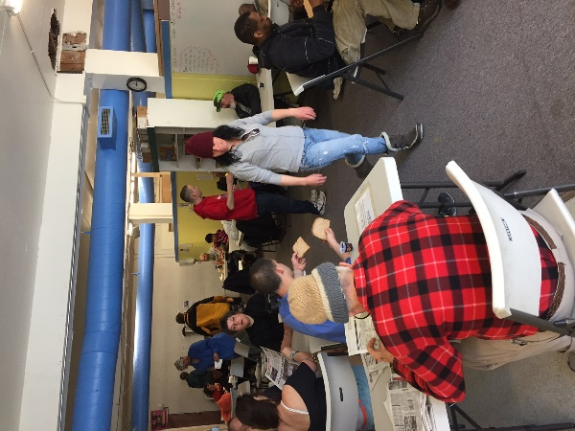
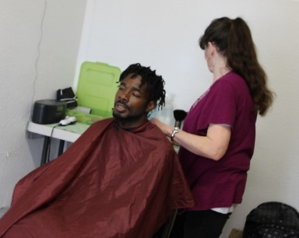
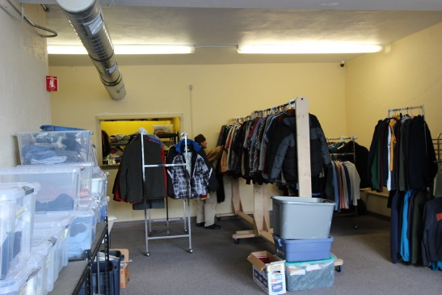
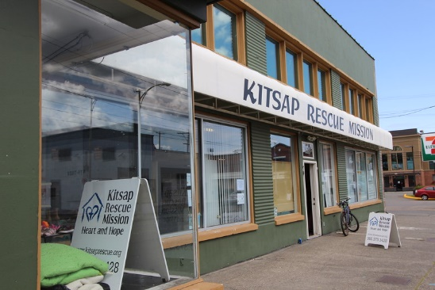
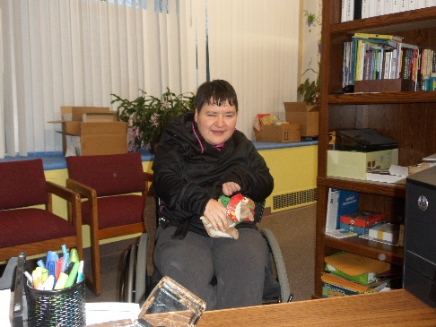
In January we were granted a temporary occupancy permit for the Building at 810 6th Street in Bremerton and decided to move the administrative offices, Dayroom, clothing distribution and hairstylist to the building. It was better located and allowed us to develop mini-services like the ones we will operate when the building is complete.
Dayroom in full swing!
I need a Hair Cut!
Donation Center
Open for Business
Mandi says, ‘nice office, Dad’
Our Volunteers – The Heart of the Mission
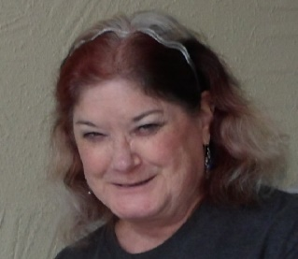
The Mission could not operate without the support of our faithful volunteers. Each day at our five meal sites, these servants of God bring their smiles and warmth to help us deliver help and hope. We also were able to provide volunteer opportunities to a larger number of volunteers this year, and they provided over 5,000 hours of service to the community through the Mission.
Sonya Hughes
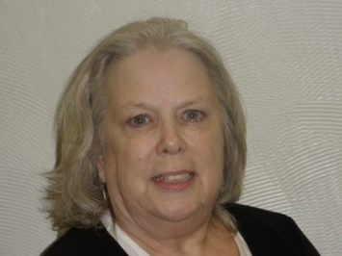
Sue Battin has moved into the position of Volunteer Coordinator. Her year of working with the clothing and meals make her a great fit for this position. Because of this, Sonya Hughes has stepped into the Donations Coordinators Position.

Sue Battin

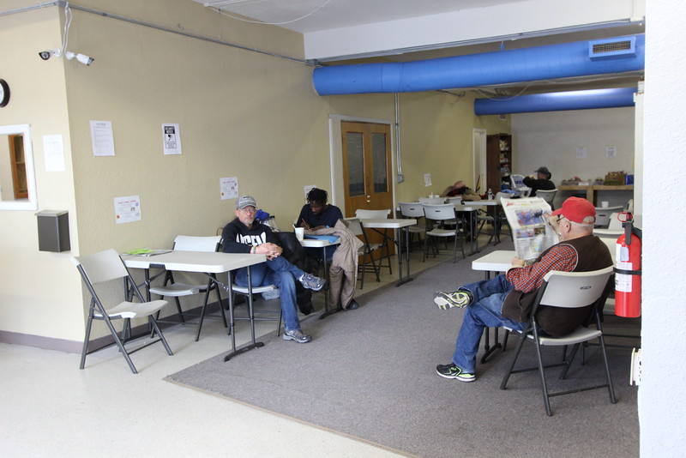
Our Dayroom continues to be in the forefront of our Mission’s services. This year we moved our Dayroom to the new building on 6th street. The Dayroom continues to provide our volunteers with the opportunity to spend time with the guests and make connections that will lead to lasting change. We have also added case management services to the Dayroom.

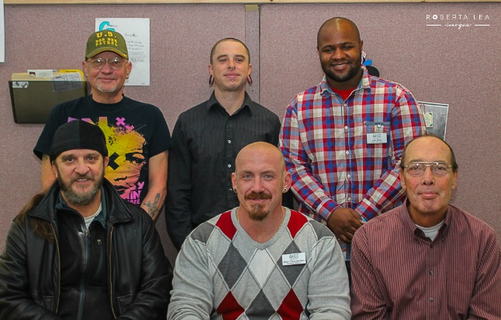
The Fresh Start Program house has also been served by a number of volunteers that have provided deep cleaning and maintenance of our current facility, as well as praying with the men.

Thank You, Volunteers!
FINANCIALS
The following charts provide a detailed breakout of our income and expenses for the year:

 | Actual | Budgeted
Administration | $54,181 | $75,500
Fundraising | $90,015 | $123,000
Program | $305,928 | $151,250
 | $450,124 | $349,750

From the Executive Director:
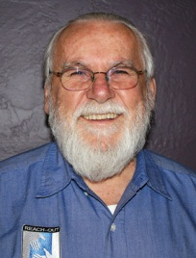
Dear Partners,
A Year of Growth is what we saw in 2015 at the Mission. Not only in the contributions of the community, but in the services offered to the individuals that visit us. We added a number of positions. Nancy Olsten was added as a volunteer to enhance our educational services and came to us from the Rescue Mission in Tacoma. Alina Keele also started as our Veterans Coordinator because we saw a real need to ensure that our veterans were getting the services that they were due. And, finally, Glen Petroski came on as our volunteer Facility Maintenance man and has proven to be a real asset to the Mission.
But the most exciting thing for me was to see so much growth in our Men in the Fresh Start Program.
One other area of growth has been in our Board. This year, we were accepted to participate in an Association of Gospel Rescue Missions initiative called ‘Ripple Effect’. With a grant from the Murdock Foundations, eight Rescue Missions from the Pacific Northwest were selected to participate in a nine month board training process using the Carver Model. We will begin training in January of 2016. Stay tuned to more information on this great project.
Thank you for helping us to help others in our community!
Sincerely,
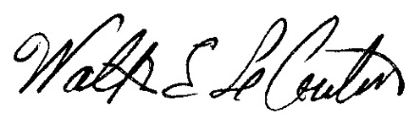
Walter Le Couteur
Executive Director

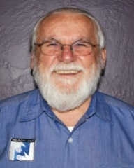
Staff
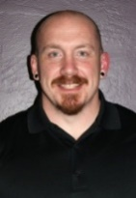
Walt Le Couteur Executive
Director (volunteer)
Mike O’Shaughnessy
Program Director
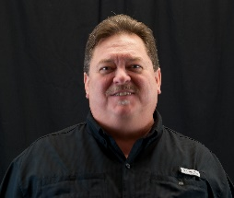
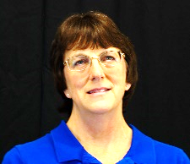
Jenny Kucera
Executive Assistant (volunteer)
Mark R. Peterson
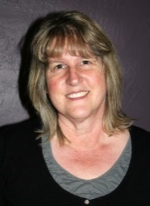
Operations Manager
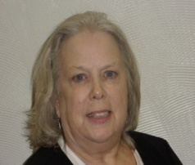
Deb Enyeart
Bookkeeper
Sue Battin
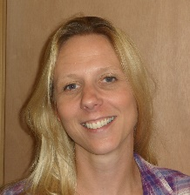
Volunteer Coordinator (volunteer)
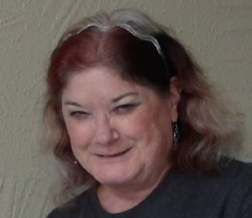
Jennifer Grimm
Case Manager (Intern)
Sonya Hughes
Donations Coordinator (Volunteer)
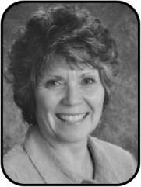
Nancy Olsten
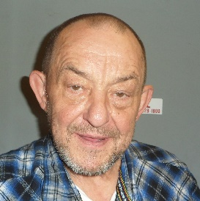
Education and Employment (volunteer)
Glen Petroski
Facility Maintenance (volunteer)
Alina Keele
Veteran’s Advocate (volunteer)

Board
Walt Le Couteur – President
Joe Summers – Vice-President (BITTS)
Rick Warfield – Secretary
Jason Van Liew – Member
Eugene Swenson – Member (Faith LiNK)

Kitsap Rescue Mission exists to assist the homeless and poor of Kitsap County as they work toward restoration of body, mind and spirit through Christ centered programs.

PO Box 1497, Bremerton, WA 98337 ~ location 810 6th St, Bremerton ~ Phone: 360-373-3428 ~ www.kitsaprescue.org
Kitsap Rescue Mission is a Washington State Non-Profit Corporation under IRS 501(c)(3) exemption and is registered with Washington State’s Charities Program as required by law. Additional information is available by calling 800-332-4483 or visiting www.sos.wa.gov/charities Registration #27830. All donations are tax exempt.

